**NAAN MUDHALVAN PROJECT**

Team leader:

S.Sarmi

Team members:

* J.Shreejaa
* R.Subhashini
* K.Suja

**Visualisation Tool for Electric Vehicle Charge and Range Analysis**

1.**INTRODUCTION**

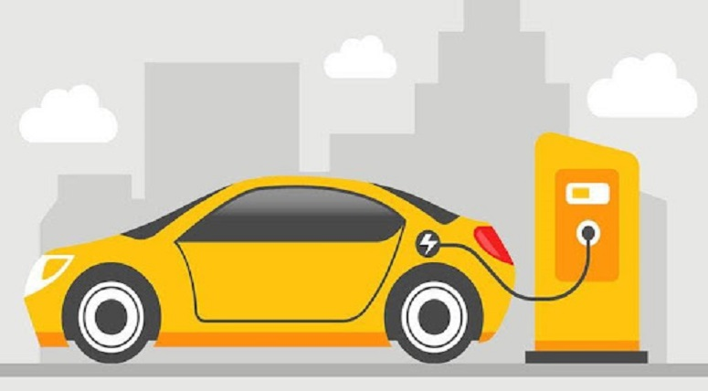

1.1 OVERVIEW

Electric vehicles (EVs) are a promising technology for achieving a sustainable transport sector in the future, due to their very low to zero carbon emissions, low noise, high efficiency, and flexibility in grid operation and integration.

1.2 PURPOSE

Electric vehicles are more efficient, and that combined with the electricity cost means that charging an electric vehicle is cheaper than filling petrol or diesel for your travel requirements.

2. **Problem Definition & Design Thinking**

2.1 Empathy map



2.2 Ideation and Brainstorming map







3. **Result**



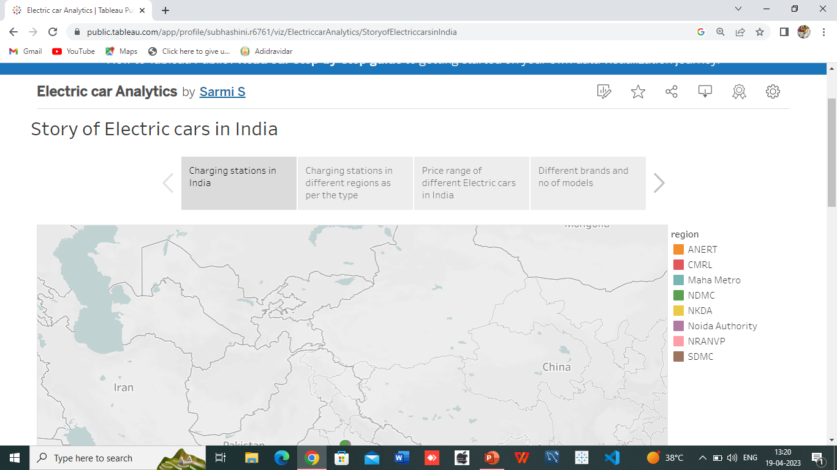



4. **Advantages and Disadvantages**

4.1 Advantages

1. Low Noise Pollution

Using electric vehicles can help to minimize noise pollution. The advantage of electric vehicles is that they produce no noise.

2. Secure Environment

Every human being's primary priority is to protect the environment.Every fuel-powered automobile causes environmental damage, as we are all aware.

3. Low Maintenance Cost

Electric motors propel electric cars, necessitating less maintenance than conventional automobiles.

4.2 Disadvantages

* Low Speed and Range

An electric car will not be able to go vast distances. Electric vehicles cannot travel farther at a faster rate of speed than those powered by engines if speed is the issue.

* Low Price on Selling

Even though fuel-powered cars are expensive to maintain, they sell for a high price.After operating an electric car, the relevance of its capacity reduces substantially, resulting in a low selling price.

* Battery Expenses

Although electric vehicles do not utilize gasoline, the batteries that power them are quite powerful.

5. **Applications**

It is used in the electric motors, batteries, inverters, wiring and in charging stations because of its durability, malleability, reliability and superior electrical conductivity.

6. **Conclusion**

So, in conclusion, electric cars have both advantages and disadvantages. They are a great way to minimize environmental pollution but also have certain disadvantages.

7. **Future scope**

* There are no emissions:

Electric automobiles are being developed primarily because they do not emit any pollution when driving. It's the best road transportation solution at a time when global CO2 emissions and air pollution must be drastically cut.

* Access to city centres is unrestricted:

Aside from the fact that more cities are implementing LEZs, these zones are also growing in size and strictness with time.

8. **Appendix**











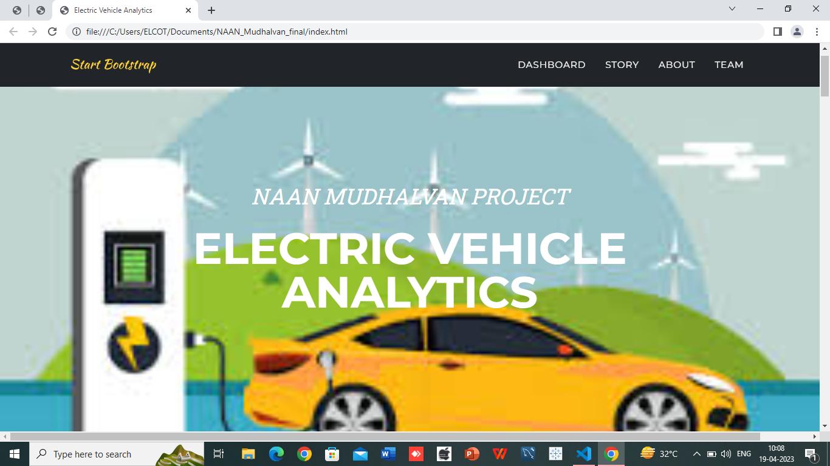

THANK YOU